1) One of the fields on a form contains a text box which accepts numeric values in the range of 18 to 25. Identify the invalid Equivalence class.

a) 17

b) 19

c) 24

d) 21

Ans:

17 fall under an invalid class

Class I: values < 18 => invalid class

Class II: 18 to 25 => valid class

Class III: values > 25 => invalid class

2) Input Box should accept the Number 1 to 10. Identify Equivalence partitioning and Boundary values for testing

Ans:

Test cases for input box accepting numbers between 1 and 10 using Equivalence Partitioning:

* One input data class with all valid inputs so we can pick a single value from range 1 to 10 as a valid test case and if selecting other values between 1 and 10 then the result will be the same. So one test case for valid input data should be sufficient.
* Input data class with any value below 1 as an invalid input data test case.
* Input data class with any value greater than 10 as an invalid input data test case.

Test cases for input box accepting numbers between 1 and 10 using Boundary value analysis:

* Test cases with test data exactly as the input boundaries of input domain(values 1 and 10)
* Test data with values just below the extreme edges of input domains ( values 0 and 9)
* Test data with values just above the extreme edges of the input domain (values 2 and 11)

3) Why is Equivalence & Boundary Analysis Testing used?

Ans:

Equivalence partitioning

* Equivalence partitioning is the black box design technique
* Dividing the test input data into a range of values and selecting one input value from each range.
* We used this technique because it reduce an infinite number of test cases to a finite number and it also ensures that selected test cases are still effective test cases which will cover all possible scenarios

Boundary value Analysis:

* Boundary value analysis is the black box test design technique
* it is used to find the errors at boundaries of the input domain rather than finding those errors in the center of input.
* Each boundary has a valid boundary value and an invalid boundary value

**4)** Write Test Cases For This Scenario:

If A Job Fails It Should Get Restarted Again. This Should Happen For Three Times. If It Fails again, then It should quit

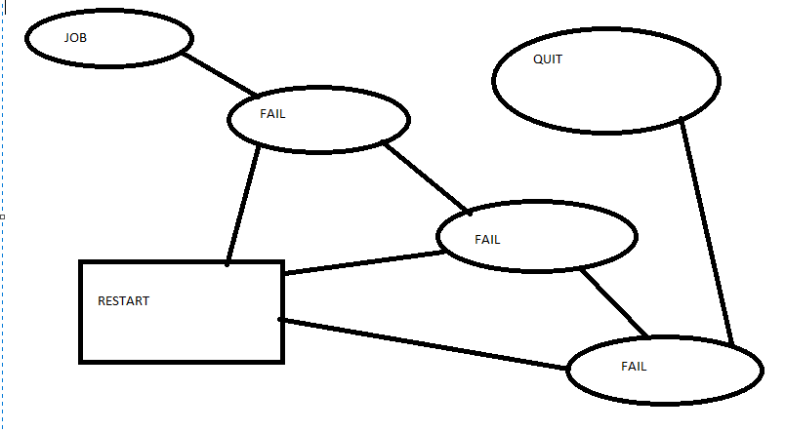

* A starts the job by clicking job button and if it fails then it should come out and get restarts and Log=1
* Again click the job button if it fails then it should come out and get restarts and Log=1+1(2)
* Again click the start button if it fails then it should come out and get restarts and Log=2+1(3)
* If log =3 then quit

5) Write The Test Case/scenario For A Login Page?

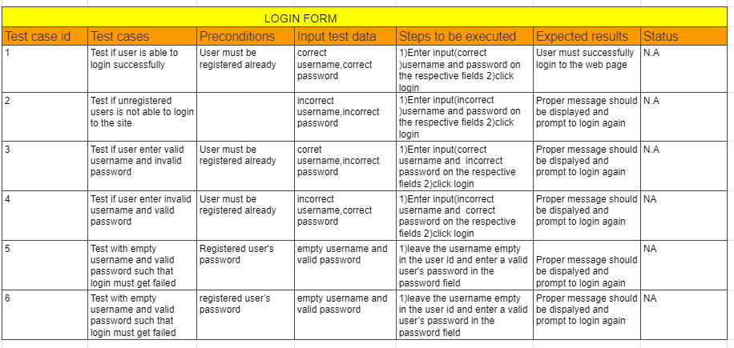

6) What Are The Test Cases/Scenarios For Mouse?

Test case 1: Verify that when we click the right mouse button is it going to open a list of that particular file or anything.

Expected: it opens the list regarding that file

Test case 2: Verify that when we click the left mouse button twice is it going to open that particular file or not.

Expected:It opens the particular file.

Test case 3:Verify the scroll button scroll the particular page or not

Expected: It scrolls the page down or up.

Test case 4:Check that the company name or logo appears on the mouse or not

Expected:The name and logo should be clearly visible to the user

Test case 5:Check that does any light blinks in the mouse when it is connected

Expected:Light should be visible to the user when it is connected to the system

Test case 6:Check drag and drop functionality of the mouse is working fine or not

Expected:Drag and drop of particular text or anything work correctly

Test case 7:Check that the mouse is a wireless mouse or wired mouse

Expected:User should be able to to see whether the mouse is a wireless or wired mouse

Test 8:Check that mouse pointer visible(cursor) on screen or not when mouse connect with system successfully

Expected:Mouse should be connected to the system and cursor is visible to the user and the user is able to move the cursor.

Test case 9:Verify that if mouse has the scroll button

Expected:Scroll button should be clearly visible to the user

Test case 10:Verify that icon name showing or not when hover mouse on object

Expected:Icon name should be clearly visible to the user when hover mouse on object

7) Write test cases/scenarios to verify the functionality of a printer?

Test case1: Switch to landscape orientation

Expected:when we printed,the diagram should appear in landscape orientation

Test case2:Switch to portrait orientation

Expected Result: when we printed,the diagram should appear in portrait orientation

Test case3:Change the paper size

Expected Result: when we printed,the diagram should appear on the correct paper size

Test case4: Switch to a color printer

Expected Result: When we printed, the diagram should be sent to the color printer

Test case5:Switch to a different printer

Expected Result: When we printed, the diagram should be sent to alternate printer

Test case6:If we select Orientation =Landscape

Expected Result: All margins should be automatically reset to default values

Test case7: Ensure correct behavior of application with Print functionality.

Expected:The printer should connect to the machine and open the application and click on Print and Verify printouts in all the views.

Test case8: Ensure that application behaves correctly if printer is not available.

Expected:no printer should connected to the machine and open the application and click on Print and proper message appears for printer unavailability

Test case9:Switch to the plotter

Expected Result: When we printed, the diagram should be sent to the plotter

Test case10:Make changes to the setting and click the Default button

Expected Result: Settings should revert to defaults

8) Write down test case/scenarios to list down possible steps to test a smartphone

Test case 1:check whether battery is placed in phone or not

Expected:Batter should be placed in phone correctly

Test case 2:check whether SIM card is placed in phone or not

Expected:SIM card should be placed in phone correctly

Test case 3:Check whether smartphone is starting or not

Expected:After inserting battery and SIM card,smartphone should start and display welcome screen

Test case 4:Check whether smartphone is able to connect the network or not

Expected:smartphone should accept the network and show network status

Test case 5:Check that when smartphone is working then inserting and removing charger do not cause any problem and proper message is displayed when charger is inserted in device

Expected:smartphone should charge its battery and appropriate message should be displayed

Test case 6:check that user can accept call

Expected:smartphone should be able to play a ringtone and vibrate. User should be able to accept by pressing call acceptance(green button)

Test case 7:check that user can reject the call

Expected:Expected:smartphone should be able to play a ringtone and vibrate. User should be able to reject call by pressing call rejection(red button)

Test case 8:check that user can type a message

Expected:User should be able to press all alphanumeric key and enter and delete key should work

Test case 9:check whether balance amount available or not

Expected:User should be able to check balance amount from mobile service provider

Test case 10:check whether speakers or not

Expected:Speakers should function properly so that user can listen to ringtone and songs

9) There is a text box which accepts numbers from 1-10. List down the test data which needs to be tested for Boundary value analysis.

Ans:

Test conditions:

* Any Number greater than 10 entered is considered invalid.
* Any Number less than 1 then it is considered invalid.
* Numbers 1 to 10 are considered valid

Testcase1: Boundary value for a text box = 0

Expected value: System should not accept because it is invalid

Testcase2:Boundary value for a text box = 1

Expected value: System should accept because it is valid

Testcase3: Boundary value for a text box = 2

Expected value: System should accept because it is valid

Testcase4: Boundary value for a text box = 9

Expected value: System should accept because it is valid

Testcase5: Boundary value for a text box = 10

Expected value: System should accept because it is valid

Testcase6: Boundary value for a text box = 11

Expected value: System should not accept because it is invalid

Testcase7:Nominal value=5

Expected value:System should accept because it is valid

10) Suppose you have a bank account that offers variable interest rates:

5% for the first $1000 credit;

1% for the next $1000;

And 1.5% for the rest.

If you wanted to check that the bank was handling your account correctly what valid input partitions might you use?

Ans:

Invalid: -0.01 $, alphabets etc

Valid-0.5% : 0.00 1000.00

Valid -1% : 1000.01 2000.00

valid-1.5% : 2000.01

3 valid and one invalid condition

11) A mail order company charges $2.95 postage for deliveries if the package weighs less than 2 kg, $3.95 if the package weighs 2 kg or more but less than 5 kg, and $5 for packages weighing 5 kg or more.

Generate a set of valid test cases using equivalence partitioning.

Ans: Input values to be checked: 0,1.1,2.2,5.5

Invalid: 0 kg => 0

Valid: 0.001kg-2kg => 1.1

Valid:2.001kg- 5 kg =>2.2

Valid:5.001 or more =>5.5

12) Boiling point of water is at 100 degrees Celsius. Determine the boundary values

Ans:

* The boundary is at 100 degrees Celsius
* So the 3 values are: 99 degrees, 100 degrees, 101 degrees

13) Exam pass – for 40 marks; merit at 60 and above; and distinction at 80 and above.

Determine the boundary values

Ans:

* 3 value boundaries would be 39, 40, 41 for pass
* 59, 60, 61 for merit
* 79, 80, 81 for distinction

14) Order numbers on a stock control system can range between 10000 and 99999 inclusive. Which of the following inputs might be a result of designing tests for only valid equivalence classes and valid boundaries:

a) 1000, 5000, 99999

b) 9999, 50000, 100000

c) 10000, 50000, 99999

d) 10000, 99999

e) 9999, 10000, 50000, 99999, 100000

Ans:

c) 10000,50000,99999

15) A program validates a numeric field as follows:

Values less than 10 are rejected, values between 10 and 21 are accepted, values greater than or equal to 22 are rejected. which of the following input values cover all of the equivalence partitions?

a. 10,11,21

b. 3,20,21

c. 3,10,22

d. 10,21,22

Ans:

c) 3,10,22

Class I: values <= 9 => invalid class

Class II: 10 to 21 => valid class

Class III: values >= 22 => invalid class

16) Which test cases are written first: white boxes or black boxes?

Ans:

* Black box test cases are written first and white box test cases later
* In order to write black box test cases we need the requirement document and design or project plan

17) Can you explain requirement traceability and its importance

Ans:

* Requirement Traceability Matrix is a document that traces all the user requirements with test cases.
* It captures all requirements which are given by the client in a single document
* The main purpose of the Requirement Traceability Matrix is to validate that all requirements are checked via test cases so that no functionality is unchecked during testing.
* It is one of the most important reports that provides the detailed test coverage to the test cases
* 100 % test coverage can be found out using the RTM and there is less chance of missing any requirement in testing. This is one of the most important advantages of preparing the RTM.